Standard | Items:
3.OA.01 -  Interpret products of whole numbers, e.g., interpret 5 × 7 as the total number of objects in 5 groups of 7 objects each. For example, describe a context in which a total number of objects can be expressed as 5 × 7. | 3.0  1. Draw a model to find the total number.  8 groups of 3  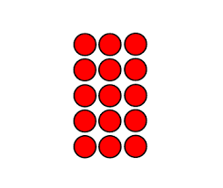  2. Write a multiplication sentence to describe the picture of counters above.  _____________________
2.0

- Circle the multiplication sentence that represents the array.

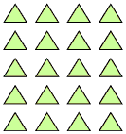

- 20 x 5 = 4
b. 20 x 4 = 5
c. 5 x 4 = 20

2. Write a multiplication equation to represent the array below?
_______ x ______ = _______

3. Draw a picture to show 4 groups of 7 stars.

3.OA.02 -  Interpret whole-number quotients of whole numbers, e.g., interpret 56 ÷ 8 as the number of objects in each share when 56 objects are partitioned equally into 8 shares, or as a number of shares when 56 objects are partitioned into equal shares of 8 objects each. For example, describe a context in which a number of shares or a number of groups can be expressed as 56 ÷ 8. | 3.0  Draw a model to represent this problem.  $21÷ 7 = 3$  b. Write a division sentence to describe the picture of  counters.  _____________________
2.0

- Circle the division sentence that represents the array.

- 4 ÷ 5 = 20
b. 20 ÷ 5 = 4
c. 5 ÷ 4 = 20

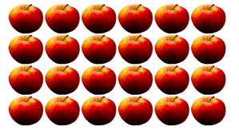

2. Write a division sentence to match the picture of the apples.

_______ ÷ _______ = ________

3. Draw a picture below to solve 35 ÷ 5

3.OA.05 -  Apply properties of operations as strategies to multiply and divide. Examples: If 6 × 4 = 24 is known, then 4 × 6 = 24 is also known. (Commutative property of multiplication.) 3 × 5 × 2 can be found by 3 × 5 = 15, then 15 × 2 = 30, or by 5 × 2 = 10, then 3 × 10 = 30. (Associative property of multiplication.) Knowing that 8 × 5 = 40 and 8 × 2 = 16, one can find 8 × 7 as 8 × (5 + 2) = (8 × 5) + (8 × 2) = 40 + 16 = 56. (Distributive property.) | Separate list for them of properties. Not on the test.  See properties posters in Rubicon Math YLC CMBA Trimester 2, as a support for these tasks.  Word Bank:  Commutative Property of Multiplication  Associative Property of Multiplication  Distributive Property  Zero Property of Multiplication  Identity Property of Multiplication  Inverse Operation  3.0  a. Use one of the properties of operations to show how this equation could have been solved.  6 X 4 = 24  b. Use one of the properties of operations to show how this equation could have been solved.  35 ÷ 7 = 5
2.0

1. Which shows the correct way to solve for 4 X 12?

- (2 x 6) + (2 x 6)
- (4 x 10) + (4 x 2)
- (4 x 6) + (2 x 6)
- (4 x 8) + (4 x 3)

2. Draw a line to connect equal expressions or values:

4 x 6 (6 x 2) + (6 x 1)

6 x 3 (8 x 5) + (8 x 2)

8 x 7 6 x 4

7 x 4 7 x 2 x 2

3. Fill in the missing factors.

6 x 7 = ( ____ x 7 ) + ( ___ x 7 )

4. Find the unknown factor. Use the Commutative Property.

___ X 3 = 30

3 X ___ = 30
3.NF.01 -  Understand a fraction 1/b as the quantity formed by 1 part when a whole is partitioned into b equal parts;  understand a fraction a/b as the quantity formed by a parts of size 1/b. | 3.0  - What unit fraction is shaded gray?  ______________________  b. Write the fraction of shaded boxes.  ______________________
2.0
a. How many equal parts are below?

______________________
b. Write the unit fraction for the shaded part below.

______________________

c. Shade two parts. Write the fraction of the shaded parts.

______________________

